# MongoDb Developer Setup

1) Download mongodb from : <https://www.mongodb.org/downloads#production>

2) Add the following to the PATH environment: <MongoHome>/bin

eg : C:\Program Files\MongoDB\Server\3.2\bin

3) Extract the folder into required directory and create the following folder directory structure in it.

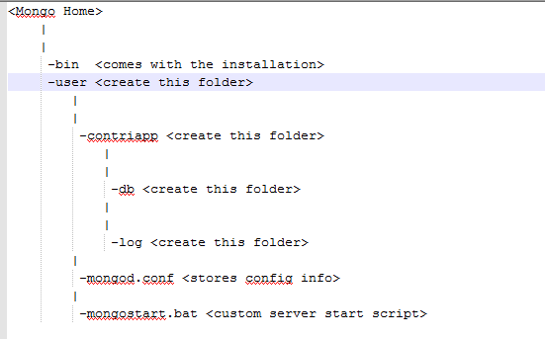

4) copy **mongod.conf** and **mongostart.bat** into the above directory.

5) The 32bit version might not be able to run the wiredTiger storage engine of mongodb.

In this case refer to the following comment in mongostart.bat

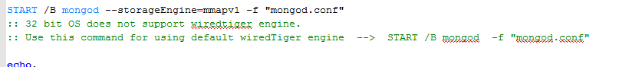

6) Type : ***show dbs*** in the shell. It should show you the default databases in mongodb.